**Multiphysics Approach to Design and Optimization of Hot Structures Subject to Engine Acoustic Loading**

Topic Area: RQ16-36: Aerothermoelastic Analysis Methodologies for Aircraft Design

AFRL POC: Dr. Philip S. Beran

*Student*: **Admir Makas** (primary author)

*Advisor*: **Dr. Ramana Grandhi**

Wright State University

**Problem Statement**

Ever since the advent of turbine engines, acoustic loading of the neighboring structures has been noted as a significant source of fatigue damage that tends to reduce the intended life cycle of affected components. As early as 1950’s, acoustic loading was identified as a critical parameter that warrants consideration in the early design of aircrafts. Despite this observation, acoustic loads have received little attention in initial design concepts due to the complex nature of the dynamic problem that is inherent in acoustic related analysis, which can make analysis both computationally and time demanding. Additionally, acoustic loads are thought to be relatively small in magnitude when compared to structure loads imposed by aerodynamic and thermal effects. As a result, over the past 70 years there have been notable fatigue related issues as a direct consequence of poor acoustic loading considerations. To remedy the impact of these early failures, significant monetary and time expenditures are required in terms of increased frequency of unplanned inspection and repair intervals.

As aircraft designs become increasingly complex due to stealth and high speed flight requirements, the role of acoustics will become more significant and must be treated in a multidisciplinary manner in conjunction with aerodynamic and thermal loads. This is especially true for Efficient Supersonic Air Vehicles (ESAV) and Engine Exhaust Washed Structures (EEWS) that are often found in embedded engines aircraft design. Since current design practices do not lend themselves to through treatment of multi loading effects that structures may experience due to combined loading (aerodynamic, thermal, and acoustic loading), the final designs are not optimal. This lack of analysis lead to early skin failures on the upper wing section of the F-15 fighter, which is a generation 4 aircraft. It is only natural that this issue is propagated to generation 5 aircraft such as the B-2 spirit stealth bomber, where aft-deck of the embedded exhaust structure fails prematurely due to a combination of thermal and acoustic loads. Above two examples clearly demonstrate a need to develop better physical understanding of the interactions between acoustic and thermal loading within the embedded exhaust structure. More specifically, work proposed herein aims to employ a coupled fluid-structure model of the exhaust structure under the acoustic and thermal loading to accomplish following tasks:

* Incorporate heat transfer analysis of the coupled fluid-structure EEWS model to ascertain the temporal distribution throughout the structure.
* Use the temperature distribution results to obtain thermal response of the EEWS structure. Following this, perform modal analysis on the fluid-structure model in order to determine dynamic response and the coupling nature of the fluid and structure components. At this stage fidelity levels of the model are also studied.
* Utilize the modal analysis results in conjunction with periodic and random dynamic loading in order to generate frequency response spectra, which can be used to simulate stress response of the structure.
* Utilize stress response for topology optimization in conjunction with continuous sensitivity analysis.

Accomplishing the above stated tasks will help further understanding of thermal and acoustic loading interactions. It is especially interesting to study the effects thermal buckling has on acoustic loading within the exhaust structure, which can have profound impact on fatigue performance of individual panels that comprise the complete system. The methods developed by the proposed work will give rise to novel design configurations that otherwise would not be immediately discernible by conventional design practices. Consequently, this advanced treatment of the acoustic loading effects will serve to reduce unexpected failure occurrences due to lack of physics in initial design phase. This will in turn reduce unexpected repair costs and schedule delays for future aircraft platforms.

**Background**

As stated in the prior section, acoustic vibrations became a significant source of loading, which the aircraft has to sustain during operation. This was the result of incorporating jet engines in the mainstream aircraft design in the 1950’s. In these very early inceptions of jet engines, it became quickly evident that secondary structures that were in the vicinity of the jet engine experienced fatigue failures [2]. As these types of failures became more frequent, government agencies of that time such as National Advisory Committee for Aeronautics (NACA, today known as NASA) began to study acoustic effects of jet engine noise on surrounding components [2-4]. Majority of failures experienced were in the aircraft skin and exhaust structures near the outlet [3]. Acoustic loading driven by the jet engine noise is typically occurring in high frequency ranges that can be as high as 1000 Hz [5]. This translates to more than a million fatigue cycle loads in a single flight. Since acoustic loading is a high cycle fatigue phenomenon, majority of fatigue life is spent in initiating a crack. This is followed by a shorter period of crack growth until either the defect is discovered or failure occurs [6]. If, however a damage site is already present due aerodynamic and/or thermal loads, then fatigue life is drastically shortened since little to no operational life of the aircraft is spent initiating a damage site. This deleterious multi-loading interaction can cause panels to fail less than 10% into the service life [7]. These sort of fatigue cases lead NACA even in the 1950’s to call for acoustic analysis incorporation early in the design process. Failure to do so was attributed to extensive rework and repair of the affected areas, which often carried a heavy price tag [8].

Design challenges for the modern aircrafts have become more daunting and influence of acoustic loads has become more prominent as engines become more powerful. This is mainly driven by the need to develop aircraft that have reduced radar, infrared, and visual signatures. Additionally, there has been a push to develop more efficient airframes, which are capable of sustained supersonic and hypersonic flight. Programs such as these fall under the scope of ESAV directive as seen in Figure 1 [9, 10]. The pictured configuration employs an embedded engine design along with the exhaust duct work as seen in Figure 2, which is subject to thermal and acoustic loads generated by the power plant. Embedded engine configurations have become a staple of 5th generation aircraft design and is only seen to gain popularity in the future. As a result, loading characteristics of modern aircraft are highly multidisciplinary in nature and possess many coupled interactions that are hard to quantify using conventional design tools [11]. Additionally, the severity of the operating conditions cause non-linear response within the structure due to both thermal and acoustic effects. Modeling becomes even more difficult since material and dynamic properties of the structure are load and temperature dependent [11, 12]. Couple these challenges with the complex shapes required for EEWS in order to ensure low visibility characteristics renders the design space open for manipulation very minimal. Conventional practices such as increasing panel thicknesses may reduce deformation due to acoustic loading but is detrimental to thermal performance of the structure. Additionally, added weight is typically not welcome in high performance designs. Given the interplay of loading mechanisms coupled with complex and restrictive shape requirements, new modeling techniques need to be developed in order to ensure robust designs.

During usual operation of the embedded engine aircrafts, the exhaust structure will experience loading that is mainly driven by the power plant. These loads will include a combination of acoustic and thermal loads. In general, thermal loads can be considered quasi-static while acoustic loads are dynamic and cause the structure to react through a band of mode shapes and frequencies as imposed by the acoustic nature of the turbine engine [7]. Depending on the severity of the thermal loads, the structure will experience expansion, which is resisted by surrounding structure and as a result thermal stresses are generated. These stresses, can in worst cases buckle selected panels of the EEWS. Besides the static structural effects, thermal loading can also modify the dynamic response of the exhaust structure through deflections imparted via material expansion. Material properties are also subject to change, which will have a profound effects on the dynamic response [13]. Acoustic experiments performed on heated aluminum panels show that the natural frequencies of the test articles are reduced. Furthermore, stiffness and damping characteristics are also changed, which can lead to increased deformations due to acoustic loads. Stiffness, tends to go down until buckling occurs, which in turn can increase stiffness since the panel takes on a new shape [14]. Panels exposed to acoustic loading have three modes of vibration in a thermal environment. Before buckling occurs the panel will oscillate about its neutral point. When buckling occurs two forms of vibratory response can take place. If acoustic energy is high enough, it can ‘push’ the panel from one buckled mode to the other. This is also called snap-through [5,14,15]. Conversely, if acoustic energy is not high enough for snap though to occur, the panel will simply vibrate about one of the buckled points. Instances of these behaviors can be seen in Figure 3 [15]. Each one of the modes pictured in Figure 3 will have a certain effect on stress response and is critical if meaningful predictions about fatigue performance are to be made.

Based on the discussion above, determining the influence of thermal loading on the dynamic response of the structure is an integral part of any posed solution to the acoustic problem. As such thermal analysis is necessary to infer the spatial temperature distribution of the exhaust structure and is shown in Figure 4. Temporal values are used to evaluate the thermal stress within the structure, which in turn are used to study the dynamic response of the coupled fluid-structure system. To the knowledge of the author this sort of analysis has not been carried out on EEWS. Since thermal and acoustic interactions are not well understood, likelihood of suboptimal design selection is likely. Therefore, to ensure sound design practices for future aircraft designs, whose requirements will only become more demanding, good understanding of thermal and acoustic interactions is integral to success.

**Technical Development and Proposed Work**

Multidisciplinary nature of the proposed work will require discretization of efforts that will build upon each other to produce a complete body of work. The first step will include the thermal analysis in order to determine the temperature distribution throughout the exhaust structure. This will be necessary in order to quantify temperature effects on the material and dynamic properties of the model, which must be accounted for to maintain proper fidelity. Once thermal contributions have been identified, modal analysis can be carried out in order to calculate the resonant frequencies and critical modes shapes that will dominate the response of the structure. Subsequently the modal analysis can be used in conjunction with a dynamic excitation force (periodic/random) to estimate displacements and stresses within the structure. Stress results can then be used to derive topology optimization results capable of sustaining the harsh operating environment found within the EEWS.

Post implementation of thermal analysis, one of the most critical aspects of the proposed work will be accurate dynamic response of the coupled fluid-structure EEWS model. Modal analysis has been carried out within our research group on simple EEWS representations at room temperature as seen in Figure 5 [11]. Work done by Vogel [11] extensively studied the dynamic response of the fluid-structure interactions of the model shown in Figure 5. Simulation results show that coupling interactions played a significant role in the modal response of the system. Failure to account for the exhaust volume inside the EEWS cavity affected the modal shapes and natural frequencies significantly enough to impact proper stress response of the model under dynamic loading. Given this prior work, the plan is to utilize this model and modify it to include thermal effects. This method of analysis will make it easier to identify thermal contributions on the modal response of the system. Effects such a buckling, frequency shifting, stiffness impacts, and modal shape changes should be clearly identifiable. Once thermal effects on the modal response have been fully characterized, the plan is to move to a more representative EEWS model, which will be comprised of more complex shapes indicative of real world EEWS designs as seen in Figure 6. It has been stated in the prior work that shape complexity induces more pronounced fluid-structure interactions. Furthermore, curved structures tend to have higher coupling tendencies between flexural and membrane modes. This effect will be studied accordingly.

Following the modal analysis and verification, the results can be used to simulate displacement and stress response of the models proposed above. Initially a simple periodic loading condition will be implemented. This will lend itself to easier interpretation of the results at the initial stage. Following this, random loading inputs shall be implemented to compare and contrast the response of the structure with respect to the periodic loading case. Attempt will be made to acquire random acoustic loading generated by a jet engine. Furthermore, tests are planned at AFRL which are intended for studying acoustic response of airframe panels. If available, loading histories from the test can be utilized for model simulations. Moreover, any future test results can be used to verify the accuracy of the multi-physics models developed.

Ultimate goal is to utilize stress predictions in conjunction with an optimization routine to achieve optimal EEWS designs that maintain proper function during operation. Work proposed herein will focus on predominantly utilizing topology optimization in an attempt to search for an optimal design. By definition topology optimization is characterized by a systematic method that seeks to find the best material distribution within the defined boundary [16]. Topology optimization is considered an iterative technique where material is either added or removed until an optimum design is achieved based on a cost function and supporting problem constraints. Many topology optimization techniques exist in the literature which include but are not limited to; Solid Isotropic Material with Penalization (SIMP), homogenization method, level set method, and cellular division method [17-20]. Each of the aforementioned methods have advantages and drawbacks, which have been effectively summarized by Deaton and Grandhi [21]. In work done by Vogel [11], modal results were used in conjunction with a periodic loading sequence to perform a panel thickness optimization on the model shown in Figure 5. Due to the spatial and multi-modal considerations, the design space may have multiple local optima which make the optimal solution dependent on the initial design configuration. To circumvent this problem a hybrid optimization technique was implemented, which combines global and local search algorithms in order to obtain an optimum design. Similar techniques may be required for topology optimization of proposed work. One of the research goals is to utilize already developed design packages such as Multidisciplinary-design Adaptation and Sensitivity Toolkit (MAST) since optimization methodologies are included within the software. Additionally, it is advantageous to study MAST capabilities on acoustic related problems, which to author knowledge has not been done.

In prior works, adjoint sensitivity analysis formulations were successfully used for stress based topology optimization of thermally loaded structures [12]. Additional progress in continuum sensitivity analysis was achieved by Koorosh et. al. [23] for fluid structure interaction problems (FSI). Aforementioned sensitivity formulations are superior to their numerical counterparts such as finite difference schemes in terms of both accuracy and computational time. Therefore, work proposed herein shall pursue analytical based sensitivity methods for the proposed topology optimization.

It was noted as far back as the 1950’s that high sound pressure levels (SPL) can cause nonlinear modal response within the structure. These nonlinearities were evident in the panel tests carried out by Lassiter and Hess [4], where frequency response functions developed skewered response shapes with increasing SPL’s seen in Figure 7. Asymmetric peaks were contributed to increase/decrease in panel stiffness. Additional effects of nonlinearities are response broadening and frequency shifting to higher values as was pointed out by [7, 8]. Curve broadening has been attributed to change in damping of the system while curve peak shift is credited to stiffness changes within the structure. Additionally, strain response is typically over-predicted if linear analysis is used in the nonlinear regime. All the aforementioned influences are seen in Figure 8. Nonlinear impact to frequency and strain response will have a significant effects on fatigue performance of the acoustically loaded structure. Therefore, as part of future work, it will be noteworthy to explore nonlinear impact to the proposed work. Presently, reduced order modeling is highly utilized to perform nonlinear modal analysis while maintaining computational times to reasonable levels [5,7,22,24]. Such a method or equivalent can be employed herein to study impacts of modal nonlinearities.

**Relevance to Previous Work**

Work proposed herein plans to expand on previous work done on the acoustic problem within our research group [11]. In past, fluid-structure interactions were studied and found to be significant. However, thermal effects and random loading effects are still to be analyzed. Ultimate goal is to unify thermal and acoustic loading under a single multidisciplinary approach, which is the goal of the proposed work. Additionally, significant amount of effort has been expended within our group on the thermoelastic problem of EEWS [10,12]. Furthermore, my advisor Dr. Ramana Grandhi is a published leader in the optimization community with over 200 authored papers. Given the past experience and expertise we are well suited to work on and tackle the problem presented by thermal and acoustic loading interactions.

**Timeline**

Timeframe below outlines the schedule of the proposed work. Throughout the course of the project I expect great deal of collaboration between my advisor, AFRL personnel, and myself. Since this work is performed at the PhD level schedule details are provided beyond the first year.

**2016 Q1**: Incorporate thermal analysis in the fluid-structure acoustic model in order to obtain thermal response the structure.

**2016 Q2**: Perform modal analysis on the simplified EEWS model to ascertain the impact thermal effects may have on the dynamic response of the structure. The results will be used to fully characterize thermal influence by contrasting the results with prior work, which did not possess thermal inputs.

**2016 Q3 (summer)**: Intent is to spend the summer working full time at the WPAFB. While there, lessons learned from the simplified fluid-solid model are used to perform thermal and modal analysis on more representative complex shape EEWS model. Effects of structure complexities with respect to thermal effects will be fully investigated.

**2016 Q4**: Thermal-modal analysis performed over the summer will be used in conjunction with periodic and random loading signals to generate displacement and stress results from the simple and complex shape models.

**2017 Q1**: Stress results from the fluid-solid coupled EEWS model will be used to perform topology optimization to generate optimal structures that will sustain combined thermal and acoustic effects. Results will be documented and methodologies delivered to AFRL.

**2017 Q2**: Study non-linear modal effects due to loading conditions. This may be performed by reduced order modeling techniques or equivalent method.

**2017 Q3**: Since modeling and analysis will be well defined at this stage, efforts can be shifted to study uncertainty quantification of the acoustic loading envelope and material properties of the model.

**2017 Q4**: Using work outlined above can be utilized to generate stress spectra for the EEWS. These spectra can be converted into loading block cycles via rainflow counting methods to be used for fatigue life estimation.

**Expected Results and Significance**

It is expected at the end of the project to obtain significant findings on thermal and acoustic interactions which govern lifecycle limits of EEWS. Results of this work will provide multiphysics modeling techniques and tools to be used in design and simulation of component reactions to thermal and acoustic loading environments. This not only applies to embedded exhaust structures but has potential to be modified for use on hypersonic vehicle skin analysis, where thermal and acoustic loading due to high speed airflow are significant. The newly gained knowledge can help save the Air Force millions of dollars by preventing inadequate designs from reaching maturity only to fail soon after service life begins.

**References**

1. Hollkamp, Joseph J., Robert W. Gordon, and S. Michael Spottswood. "Nonlinear Modal Models for Sonic Fatigue Response Prediction: A Comparison of Methods." *Journal of Sound and Vibration* (2005): 1145-163. Print.
2. Hess, Robert W., Robert W. Fralich, and Harvey H. Hubbard. “Studies of Structural Failure Due to Acoustic Loading.” *National Advisory Committee for Aeronautics*, 1957.
3. Hess, Robert W. “A Study of the Response of Panels to Random Acoustic Excitation.” Washington, D.C.: *National Advisory Committee for Aeronautics*, 1955.
4. Lassiter, Leslie W, and R. W Hess. “Calculated and Measured Stresses In Simple Panels Subject to Intense Random Acoustic Loading Including the Near Noise Field of a Turbojet Engine.”Washington, D.C.: *National Advisory Committee for Aeronautics*, 1957.
5. Vaicaitis, Rimas. "Nonlinear Response and Sonic Fatigue of National Aerospace Space Plane Surface Panels." *Journal of Aircraft* 31.1 (1994): 10-18. Print.
6. Makaš, Admir. “Effect of Rolling Induced Anisotropy on Fatigue Crack Initiation and Short Crack Propagation in Al 2024-T351.” Thesis. 2011. Print.
7. Gordon, Robert, and Joseph Hollkamp. "Reduced-Order Models for Acoustic Response Prediction of a Curved Panel." *52nd AIAA/ASME/ASCE/AHS/ASC Structures, Structural Dynamics and Materials Conference* (2011). Print.
8. Mei, C., and C.b. Prasad. "Effects of Non-linear Damping on Random Response of Beams to Acoustic Loading." *Journal of Sound and Vibration* 117.1 (1987): 173-86. Print.
9. Haney, Mark. "Topology Optimization of Engine Exhaust-Washed Structures." Electronic Thesis or Dissertation. Wright State University, 2006. *OhioLINK Electronic Theses and Dissertations Center*. 08 Jan 2016.
10. Haney, Mark A., and Ramana V. Grandhi. "Consequences of Material Addition for a Beam Strip in a Thermal Environment." *AIAA Journal* 47.4 (2009): 1026-034. Print.
11. Vogel, Ryan N. “Structural-Acoustic Analysis and Optimization of Embedded Exhaust-Washed Structures.” Diss. Wright State University, 2013.
12. DEATON, JOSHUA DAVID. “Design of Thermal Structures using Topology Optimization.” Diss. Wright State University, 2014.
13. Vogel, Ryan, and Ramana Grandhi. "Structural Acoustic Analysis and Design of Aircraft Components." *12th AIAA Aviation Technology, Integration, and Operations (ATIO) Conference and 14th AIAA/ISSMO Multidisciplinary Analysis and Optimization Conference* (2012). Print.
14. Sha, Yun Dong, Zhi Jun Gao, Fei Xu, and Ji Yong Li. "Influence of Thermal Loading on the Dynamic Response of Thin-Walled Structure under Thermo-Acoustic Loading." *Advanced Engineering Forum AEF* 2-3 (2011): 876-81. Print.
15. Ibrahim, Hesham Hamed, Hong Hee Yoo, Mohammad Tawfik, and Kwan-Soo Lee. "Thermo-acoustic Random Response of Temperature-dependent Functionally Graded Material Panels." *Computational Mechanics Comput Mech* 46.3 (2010): 377-86. Print.
16. Bendsøe, Martin P., and O. Sigmund. *Topology Optimization: Theory, Methods, and Applications*. Berlin: Springer, 2003. Print.
17. Bendsøe, Martin Philip, and Noboru Kikuchi. "Generating Optimal Topologies in Structural Design Using a Homogenization Method." *Computer Methods in Applied Mechanics and Engineering* 71.2 (1988): 197-224. Print.
18. Bendsøe, M. P. "Optimal Shape Design as a Material Distribution Problem." *Structural Optimization* 1.4 (1989): 193-202. Print.
19. Wang, Michael Yu, Xiaoming Wang, and Dongming Guo. "A level set method for structural topology optimization." *Computer methods in applied mechanics and engineering* 192.1 (2003): 227-246.
20. Kobayashi, M. H., et al. "On a cellular division method for aircraft structural design." *Aeronautical Journal* 113.1150 (2009): 821-831.
21. Deaton, Joshua D., and Ramana V. Grandhi. "A survey of structural and multidisciplinary continuum topology optimization: post 2000." *Structural and Multidisciplinary Optimization* 49.1 (2014): 1-38.
22. HEEDS MDO User Manual, Ver. 6.1, Red Cedar Technology, Inc. East Lansing, MI, 2011
23. Radu, Adrian, et al. "Prediction of the dynamic response and fatigue life of panels subjected to thermo-acoustic loading." *Proceedings of the 45th Structures, Structural Dynamics, and Materials Conference*. 2004.

**Figures**

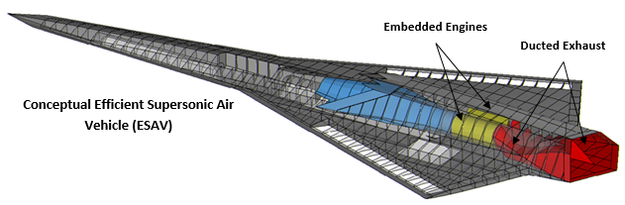

Figure 1: Embedded engine design configuration for the ESAV concept pictured above.

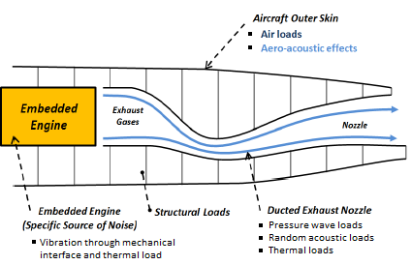

Figure 2: Typical exhaust nozzle design with the embedded engine shown.

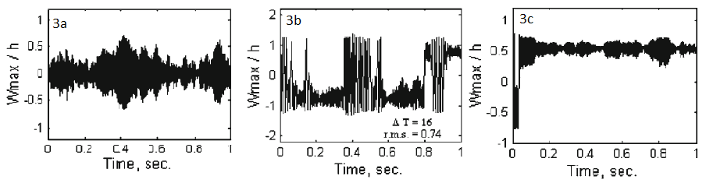

Figure 3: Dynamic response of aluminum panels subjected to thermal loading. 3a) non-buckled panel subject to acoustic loading. 3b) Post-buckled panel showing snap-though. 3c) Post-buckled panel vibrating about a buckled position.

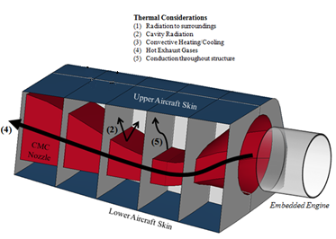

Figure 4: Thermal modeling considerations for EEWS.

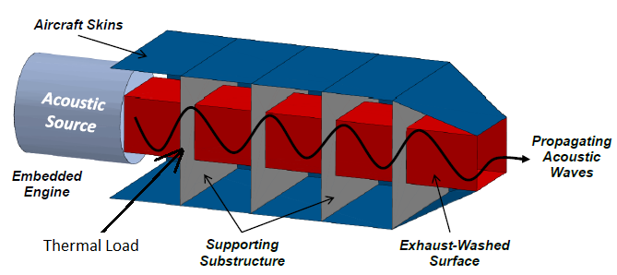

Figure 5: Simplified representation of the EEWS.

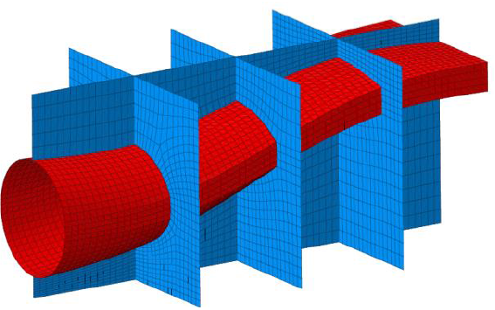

Figure 6: More representative shape for the EEWS.

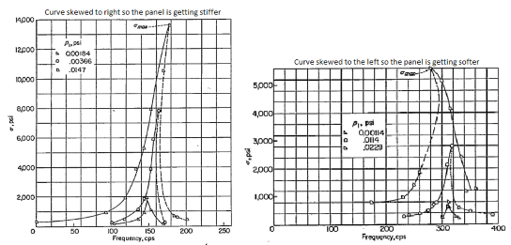

Figure 7: Asymmetric frequency response cures due to increased sound pressure levels

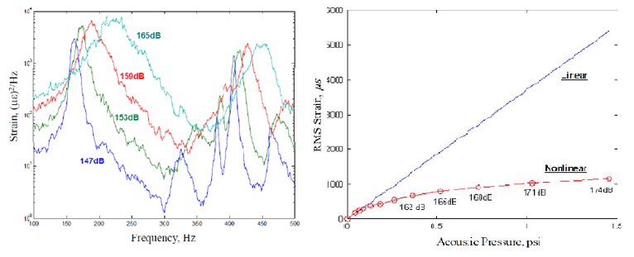

Figure 8: Frequency response function peak shifts and broadening due to nonlinear effects.